

**INTERNSHIP REPORT APPROVAL FORM**

July 1, 2019

With immense pleasure, this is to approve that the students of Sona college of technology

**Prajakta R(1517106062)**

**Raghavarshani K.S(1517106066)**

**Nalapriya D(1517106053)**

**Prasitha A(1517106063)**

successfully completed their Project and Project Report on **“University Admission Prediction”** under our guidance.

We are highly impressed with the work that they have done and commend them on their quick grasping skills. They have shown good intent to learn and have put the knowledge gained into application in the from of this project. We appreciate the hard work and commitment shown by them.

We, hereby approve that this document is completely checked and accepted by SmartBridge Technical Team. Its been an absolute pleasure to educate and mentor these students. We hope that this document will also serve as a Letter of Recommendation, to whomsover applied.

We wish them success in all future endeavors and a great career ahead.

**GD Abhishek**

AI Developer

UNIVERSITY STUDENT ADMISSIONS

BUGBUSTERS

PRAJAKTA R

RAGHAVARSHANI K.S

NALAPRIYA D

PRASITHA A

* 1. INTRODUCTION

Technology is making humans life easier day by day and Artificial Intelligence is playing a major role in it. AI is becoming a buzzword in the field of computer science. So what is AI? In computer science, artificial intelligence (AI), sometimes called machine intelligence is intelligence demonstrated by machines, in contrast to the natural intelligence displayed by humans. Colloquially, the term "artificial intelligence" is often used to describe machines (or computers) that mimic "cognitive" functions that humans associate with other human minds, such as "learning" and "problem solving".

REASONS FOR USING PYTHON IN AI (Machine learning):

As AI and ML are being applied across various channels and industries, big corporations invest in these fields, and the demand for experts in ML and AI grows accordingly. Jean Francois Puget, from IBM’s machine learning department, expressed his opinion that [Python is the most popular language for AI and ML](https://www.ibm.com/developerworks/community/blogs/jfp/entry/What_Language_Is_Best_For_Machine_Learning_And_Data_Science?lang=en)

1) A great library ecosystem

2) A low entry barrier

3) Flexibility

4) Platform independence

5) Readability

6) Good visualization options

7) Community support

8) Growing popularity

1.2-OBJECTIVES OF RESEARCH

The main objective of our project is to predict whether a student will get admitted in a university or not based on certain academic parameters. The aim is to avoid confusion among students whether they will admitted in a certain university or not.

1.3- PROBLEM STATEMENT

Our problem statement is “university admissions prediction”. The independent variables of the dataset are GRE scores, TOEFL score, university ranking, CGPA, SOP, LOR, research score. The dependent variable is the probability whether the student will get admitted or not. The probability is calculated based on the independent variables.

2-REVIEW OF LITERATURE:

The algorithm that we have used to do the prediction of the student getting admitted in the university is “POLYNOMIAL LINEAR REGRESSION”. The accuracy of this algorithm for the given student dataset is 79%

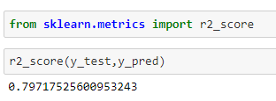

This accuracy is greater when compared to the accuracies of other algorithms

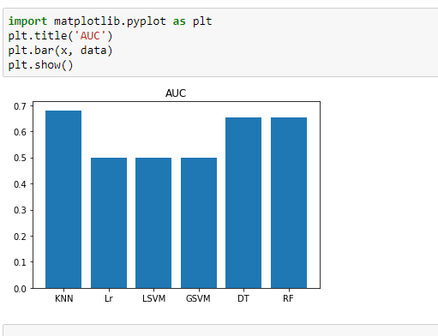

Since the dependent variable of the given dataset is continuous in nature it belongs to regression type of algorithm and polynomial linear regression is best suited for this dataset in accuracy. The model is deployed in NODERED of IBM cloud.

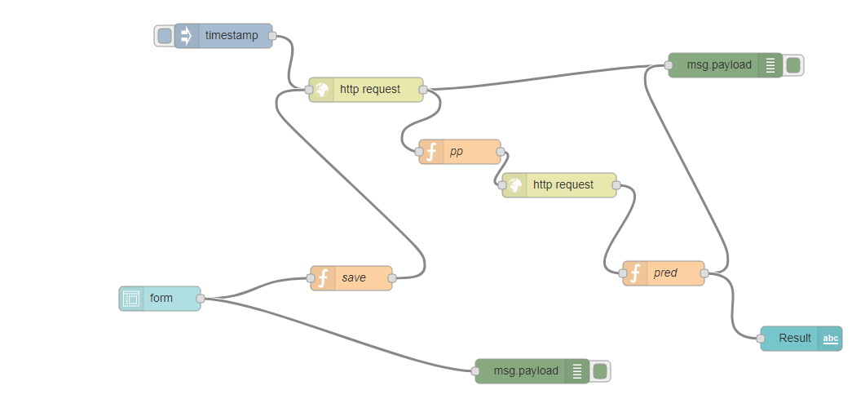

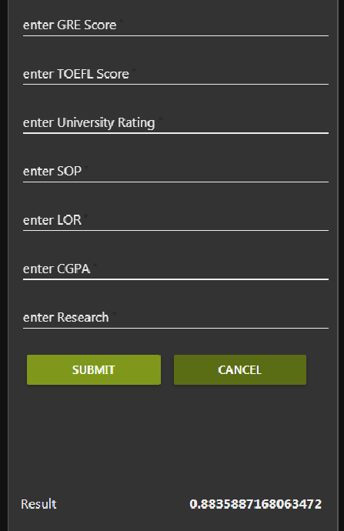The predicted results are displayed in UI configuration.

3-DATA COLLECTION

The dataset is referred from Kaggle

<https://www.kaggle.com/krishnapriya66/university-admission-prediction-using-logistic>

4-METHODOLOGY

4.1 EXPLORATORY DATA ANALYSIS

4.1.1 FIGURES AND TABLES

Pairplot of independent variable with dependent variable

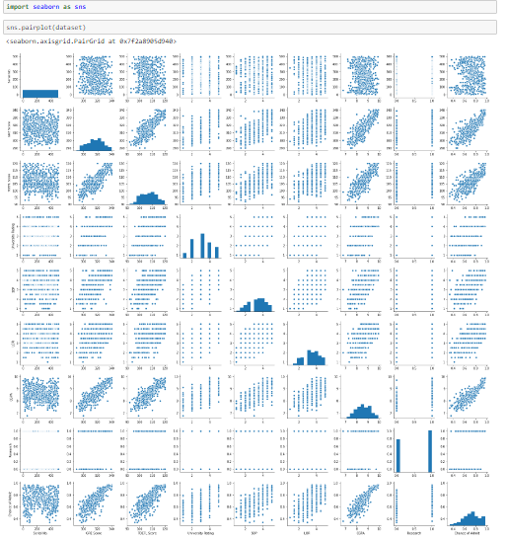

Correlation of dataset

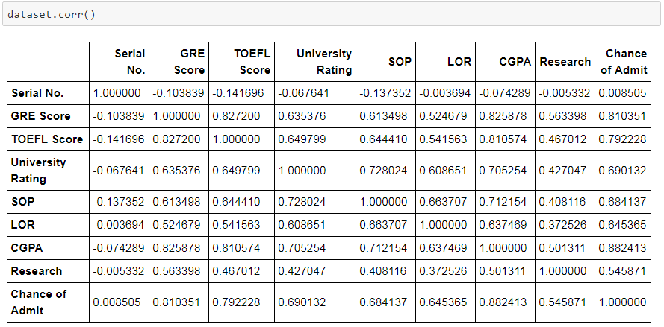

4.2 DATA MODELLING

The algorithm used for this dataset is **“POLYNOMIAL LINEAR** **REGRESSION”**

Y=A0+A1X1+A2X1^2+……. +AiXi^i

Polymial linear regression is mostly used for data which is polynomial in nature. The actual data is converted to a higher degree polynomial data and linear regression algorithm is applied.

Class polynomial features in **sklearn.preprocessing** package is used to apply polynomial features to the data

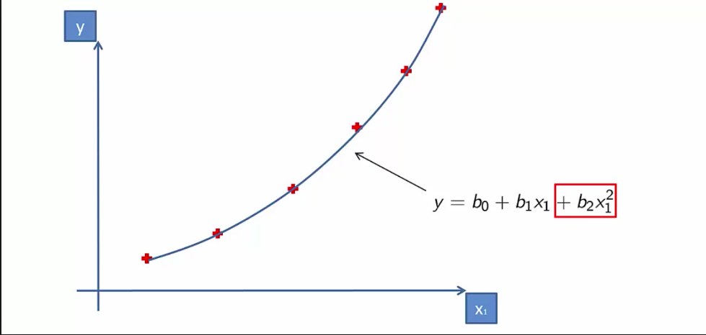 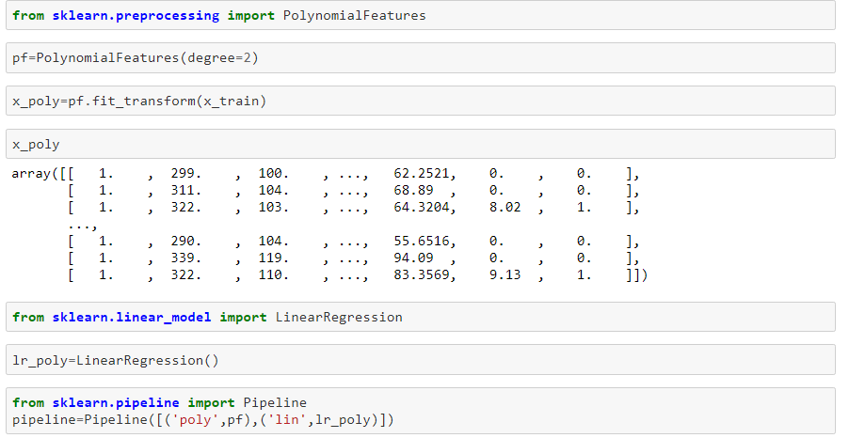

5) REFERENCES

<https://www.google.com/search?q=scikit+learn&rlz=1C1GCEU_enIN851IN851&oq=scikit&aqs=chrome.0.35i39j69i57j0l4.13791j0j7&sourceid=chrome&ie=UTF-8>

<https://www.google.com/search?q=tensorflow+tutorial&rlz=1C1GCEU_enIN851IN851&oq=te&aqs=chrome.1.69i59l2j0j69i57j0l2.2584j0j7&sourceid=chrome&ie=UTF-8>

<https://www.google.com/search?q=geeks+for+geeks&rlz=1C1GCEU_enIN851IN851&oq=geeks+&aqs=chrome.1.69i57j0l5.6087j0j7&sourceid=chrome&ie=UTF-8>

<https://stackoverflow.com/>

<https://www.google.com/search?rlz=1C1GCEU_enIN851IN851&ei=kisXXcqKNYqS9QOVuK_gCw&q=udemy+python&oq=ude&gs_l=psy-ab.1.8.0i67j0l3j0i20i263j0l5.106495.119277..124028...1.0..2.392.2909.0j4j3j4......0....1..gws-wiz.....10..0i71j35i39j0i131.wb6PVuPYHDM>

<https://www.google.com/search?q=keras&rlz=1C1GCEU_enIN851IN851&oq=keras&aqs=chrome..69i57j35i39j0l4.4399j0j7&sourceid=chrome&ie=UTF-8>

<https://www.google.com/search?q=node+red+machine+learning&rlz=1C1GCEU_enIN851IN851&oq=no&aqs=chrome.1.69i59l2j69i57j69i59j69i61j69i60.11174j0j4&sourceid=chrome&ie=UTF-8>

<https://www.google.com/search?sa=X&rlz=1C1GCEU_enIN851IN851&q=PyTorch&stick=H4sIAAAAAAAAAHWOPQ6CMABG08HE3xs4NF6gtJUAhzBxdjFQoCUtpfyEBo_jcXokJ4PSwcHxJd_38tbH0wFxhDHPaRKEIyawTpmodAFVkXa60hz2TTnYtCugmQbR6NteVVr2sGw6WCsHvv_MGtwTST17nwNbVKNAJJEZ2wXsZGV-dmA3Aw5KFnHpf0xZRW32WKbECDHYBWTMWnr3EkqsHhzYzJARGsYvAC9_26-f9ufqJ_4NFMRAyP4AAAA&ved=0ahUKEwj6j8-nro7jAhVTXn0KHSahBbQQ-BYIMA&biw=1034&bih=748>

6-CONCLUSION

The given problem statement is solved using polynomial linear regression algorithm and deployed on Node-Red

<https://parallel-universe.eu-gb.mybluemix.net/ui/#!/1?socketid=vM7EmCBvHYYwH0L7AAAL>

THANKYOU!